Group Member Project Title

* Sahil Suresh (ss06192) That’s your fare
* Ali Hashir (ah05433)
* Mehdi Raza (mr05967)

**Lets Drive! Fare Estimator**

Learning to code in class and implementing it into real world are two different things. Being inspired by Uber/Careem application and service it provides, we tried designing a similar model application that provides you a cab at your doorstep.

The program works on implementing the topics the we learnt in our classes, the core of the program is the shortest path algorithm.

**How it works?**

It asks you for the following inputs:

* Pick up location
* Destination
* Vehicle type

Enter a pick up location and destination from pool of locations, then select the vehicle type.

* It will provide following outputs:
* Map of the path
* Total Kilometers travelled
* Minimum Fare of ride
* Time duration
* Will assign you a captain from different captains
* “Happy Riding :D” message

**GUI Part:**

For the Graphical User Interface, we have used Tkinter, that allows us to make our programs interactive and provides a separate window for input and outputs. For the pick up location and destination it provides you drop down menu, for which we used comboBox package, for selecting vehicle we have radioButtons that allows you select between different vehicles. After providing these three inputs it will display the output on that window created.

**Fare calculator:**

The fare estimation and arrival time depends on the KM there are to be travelled and also on the type of vehicle that you are opting for transportation.

Total KM * Rate of 1 KM

Using; Dijsktra, tkinter module, math module, random module, Graph (locations map)

**Graph Used:**

G = {

 'Clifton teen talwar': [('Garden', 8.3), ('DHA Phase 5',3.9),('Light House',3.9) , ('Korangi',10.2)],

 'Saddar': [('Garden', 3.4), ('Shahrah-e-Faisal', 6.8)],

 'Shahrah-e-Faisal': [('Saddar',6.8),('DHA Phase 5',8)],

 'Garden': [('Clifton teen talwar', 8.3),('Saddar',3.4) , ('Bahadurabad', 5.5), ('Gulshan e Iqbal', 9), ('Light House',4)],

 'DHA Phase 5': [('Clifton teen talwar', 3.9),('Shahrah-e-Faisal',8), ('Korangi',9.9),('Light House',7.5)],

 'Gulshan e Iqbal': [('Bahadurabad', 8) ,('Garden',9)],

 'Bahadurabad': [('Gulshan e Iqbal', 8),('Garden',5.5),('Light House',7.3)],

 'Korangi': [('DHA Phase 5', 9.9),('Clifton teen talwar', 10.2)],

 'Light House': [('Clifton teen talwar', 3.9), ('DHA Phase 5', 7.5),('Garden',4),('Bahadurabad',7.3)]

 }

**Sample Working:**

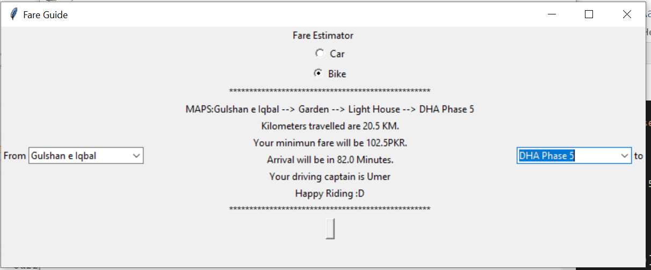

**Resources:**

* Lectures by Syeda Saleha Raza
* Labs by Miss Ayesha
* Tkinter from datacamp and YouTube tutorials

<https://www.datacamp.com/community/tutorials/gui-tkinter-python?utm_source=adwords_ppc&utm_campaignid=10267161064&utm_adgroupid=102842301792&utm_device=c&utm_keyword=&utm_matchtype=b&utm_network=g&utm_adpostion=&utm_creative=278443377086&utm_targetid=dsa-429603003980&utm_loc_interest_ms=&utm_loc_physical_ms=1011081&gclid=CjwKCAjwrcH3BRApEiwAxjdPTQw5BUaDYJH035-PAv-fctRKfERf8g--2JvufL-8ssqbSow6gbmuoRoC0YwQAvD_BwE>